Project Management Tools

Zenhub vs Jira



Edita Pronckute | S8-Graduation Internship | 2023 April

# Project Management Tools Introduction

Project management tool is a software used by the team to help plan the work, keep track of tasks and achieve the defined goals in time. The key features of a good web-based project tool are planning, estimation, resource allocation, quality and risk management. They often offer a way to breakdown work structure (WBS) and keep track of team members responsible for each task. This way planning can be improved or adjusted better with each completed assignment. Therefore, it is a vital tool for any development team.

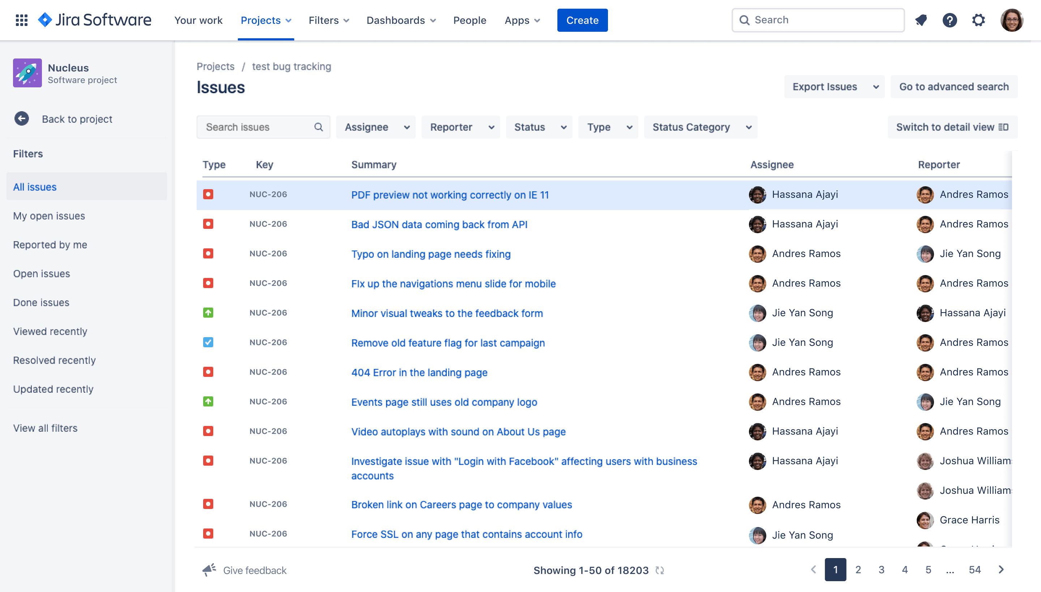

Image 1. Jira tickets view example.

Currently the team is using Zenhub, however, over time some issues (frequent bugs, downtime) and limitations (lack of features) are causing the team to consider other options. Jira is the most popular Project Management Tool at the moment and thus is being brought up for discussion a lot. This document is meant to find the benefits and drawbacks of each tool and weight them against each other. The results will be brought up to the team for consideration.

Image 2. Zenhub board example.

# Decision Criteria

There are various expectations that both products should conform to. The information was gathered via online sources, app comparisons, user reviews as well as talking with peers within the company about their experience. The options are then pitted against each other for each criterion and scored accordingly.

It is worth noting that Jira is a much older software in comparison to Zenhub. It is part of the Atlassian group, founded in 2002, while Zenhub has only been established in 2014. Naturally, there is much more user reviews available for the one that has been around longer. On the other hand, Zenhub has more reviews from smaller businesses than Jira.

The table below offers a list of the criteria, and each product is scored. 1 point for full compliance – product has the right feature or functionality, 0,5 point for partial feature or a feature with limitation (in example extra fee) in comparison with each other. 0 points for not meeting the criteria or not providing the right functionality.

# Comparison

|  |  |  |  |  |
| --- | --- | --- | --- | --- |
| **Criteria** | Zenhub Logo PNG Vector (SVG) Free Download**Zenhub** | | Jira Logo, symbol, meaning, history, PNG, brand**Jira** | |
| **Supported Platforms** | Web-based | 0,5 | Web based and most mobile platforms | 1 |
| **Market segment** | Small-Mid projects | 0,5 | Mid-Large projects | 1 |
| **Customer Support** | Business hours (Plan dependant) | 0,5 | 24/7 Live Online | 1 |
| **Onboarding** | Documentation, Webinars, In-person | 1 | Documentation, Webinars, Live online | 1 |
| **Integrations** | GitHub, Slack and ~10 others | 0,5 | GitHub, GitLab, Bitbucket, Gmail, Slack, ProductBoard, Polly, AzureApps, MSPowerApps, Miro, Compass, Salesforce, Trello, Zoom, Figma and hundreds more | 1 |
| **Documentation** | Integrated wiki for all documentation needs | 1 | Third party application needs to be integrated for an extra fee | 0,5 |
| **Pricing Policy** | Starts under 10$ per user /month | 1 | Starts under 10$ per user /month | 1 |
| **Ease of use** | Easy to set up and use | 1 | Complex set up, easy to use | 0,5 |
| **Features** | Over 50 features | 0,5 | Over 150 features | 1 |
| **Value for money** | Less value for the price | 0,5 | More value for the price | 1 |
| **Total score:** | | **7** |  | **9** |

# Conclusion

Some of the main features of Zenhub and Jira are the same or very similar. There are different types of “issues”, that can be customized, belong to an epic and a release. The issues can have labels that can be used by the team in a creative way, like help identify part of code that needs work or type of bug it marks etc. Each sprint also produces the reports that help evaluate the workload. However, each software has their own perks and cons.

Jira has much more integrations, supports all mobile platforms and is considered to offer more features or value for its price. It has an upper hand on issue tracking as it allows any type of issue to still be split into smaller tasks enabling collaboration and better work distribution. Jira allows customization of filters and components and is favoured by Twitter, Lyft, Reddit, Pinterest and others. Users can build their own functionality using JQL (Jira Query Language), which is both complex and useful. This is one of the examples of a variety of options that Jira provides at the cost of complexity, and high entrance barrier. Overall, Jira has a much wider range of features, that can make it overwhelming to set up. However, once it is set up, it will run almost autonomously.

Zenhub is mostly used for software-driven startups and scaleups with agile development teams, as it offers a rather straightforward kanban board for tracking issues and is accessible directly from the GitHub page. It allows users to tie their epics with other epics representing a bigger piece of work and is the chosen project management tool of Microsoft, Adobe, IBM, Redhat etc. Overall, Zenhub offers all core management tool features in one place: code, agile wall and documentation (to use Jira documentation a third-party app is required that is not free). Its weak points are much less reporting and charting options to use for reflection and improvement on previous sprints, and low integrations count. However, as the Zenhub grows this will probably become an issue of the past.

All in all, Jira is good for long term agile projects offering great granularity in tracking issues. It works best integrated with other Atlassian tools as it is part of a larger suite, however, Zenhub is considered a natural choice for GitHub projects as this offers great convenience for Github users. Zenhub is good to start with, but as the projects grow in size and complexity, perhaps it would be wise to move towards Jira that can support the growth better.

# References

G2. (2023). *Compare Jira and Zenhub*. Retrieved from G2: https://www.g2.com/compare/jira-vs-zenhub

Get App. (2023). *Jira vs ZenHub Comparison*. Retrieved from Get App - Product Management tools: https://www.getapp.com/project-management-planning-software/a/jira/compare/zenhub/

SaasHUb Compare Products. (2023). *ZenHub VS Atlassian JIRA*. Retrieved from Saas Hub: https://www.saashub.com/compare-zenhub-vs-atlassian-jira

SaaSworthy . (2023, April 25). *Compare Jira vs Zenhub*. Retrieved from Saas Worthy Product management Software: https://www.saasworthy.com/compare/jira-vs-zenhub?pIds=2493,3272

SourceForge. (2023). *Jira Software vs. ZenHub Comparison Chart*. Retrieved from SourceForge - Open-Source and Business Software Platform: https://sourceforge.net/software/compare/JIRA-vs-ZenHub/

Steskal, A. (2017, February 7). *Jira vs Trello vs ZenHub Comparison*. Retrieved from Medium: https://alexandrasteskal.medium.com/jira-vs-trello-vs-zenhub-6d1acb232101

TrustRadius. (2023). *Jira vs Zenhub*. Retrieved from Trust Radius: https://www.trustradius.com/compare-products/jira-software-vs-zenhub

Zenhub. (2023). *Looking for the JIRA alternative?* Retrieved from Zenhub: https://www.zenhub.com/jira-alternative

Zoho Corporation Pvt. Ltd. (2023). *What are the key features of project management tools?* Retrieved from Zoho Projects: https://www.zoho.com/projects/project-management-tools.html?zredirect=f&zsrc=langdropdown&lb=nl